WaterSOLV™ Ag Program
Questionnaire – Engagement/Proposal

Please complete online and send to HCT as a Word document, so that we can update as well as maintain this data for our mutual benefit. Send to support@hctllc.com

Questions, Comments Suggestions – teden@hctllc.com – text or call (480) 650-6955

Date
Facility / Company / Grower Company Name
City, State
Contact Name & Title
Cell Phone
Email address
Type of property (Trees, Row Crop, Grapes, tomatoes, …)
Type of irrigation – flood, sprinkler, emitter. drip
Acreage Watered
No. of Unique Water Sources
What is source of water, canal, pond, well to pond, …
Type of water, irrigation, canal, city, reclaim, …
No. Pump Stations
Pump Stations pressure (psi) and water volume (gpm)
Do you have acid injection system now and if so, what?
Do you have bulk acid tanks in use and how old are they?
Amount of water used annually just to flush salts?
Amount of water used annually watering crops?
Any underwater shell or snail issues?
What acids, if any have been used, for how long and how much?
Do you have emitter clogging issues?
Your Objectives
Timing to implement?
Timing to see results? (Normally 90-120 days)
Other
Who are your two primary sources of ag supplies?
Getting Started
Provide us water analyses
Provide us soil analyses
Send us a 16 fl. ounce water sample for Total Bacteria Analysis (do not use a Gatorade bottle)
Notes:

Next Steps

We are building a folder on your facility relating to crops, soil and water. We will use this data to serve you with our products and services.

What’s next is that we will assess your water, total bacteria and soil, do our calculations, and send you what it will take to treat your water and to condition your soil based on your wants, timing and budget. Turnaround upon receipt of the data is about 4 days.

HCT’s Water & Soil Analyses (requirements)
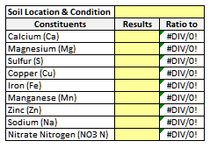
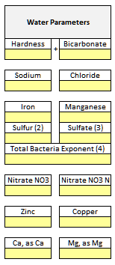

Notes:

